**Shapley - 16 Features (FI 0.60)**

Considering Shapley Feature importance values ≥ 0.60.

**Features:** FC3, Fz, F7, FT7, T4, T3, Fp2, Fp1, TP7, CP3, F4, F8, F3, O2, O1, T6.

**Machine learning evaluation using 16 Features with Feature Importance ≥ 0.60.**

|  |  |  |  |  |  |  |
| --- | --- | --- | --- | --- | --- | --- |
| Model | Accuracy | Precision | Recall | F1-score | AUC-ROC | Training Times (s) |
| KNN | 0.996986 | 0.998153 | 0.995813 | 0.996982 | 0.996986 | 0.07 |
| Random Forest | 0.988016 | 0.993962 | 0.981988 | 0.987939 | 0.988014 | 493.09 |
| XGBoost | 0.923279 | 0.941877 | 0.902170 | 0.921596 | 0.923271 | 4.94 |
| Decision Tree | 0.911134 | 0.913517 | 0.908174 | 0.910838 | 0.911133 | 30.08 |
| Extra Trees | 0.992627 | 0.997152 | 0.988069 | 0.992590 | 0.992625 | 121.96 |

**Table:** Machine learning evaluation using 16 Features with Feature Importance ≥ 0.60.

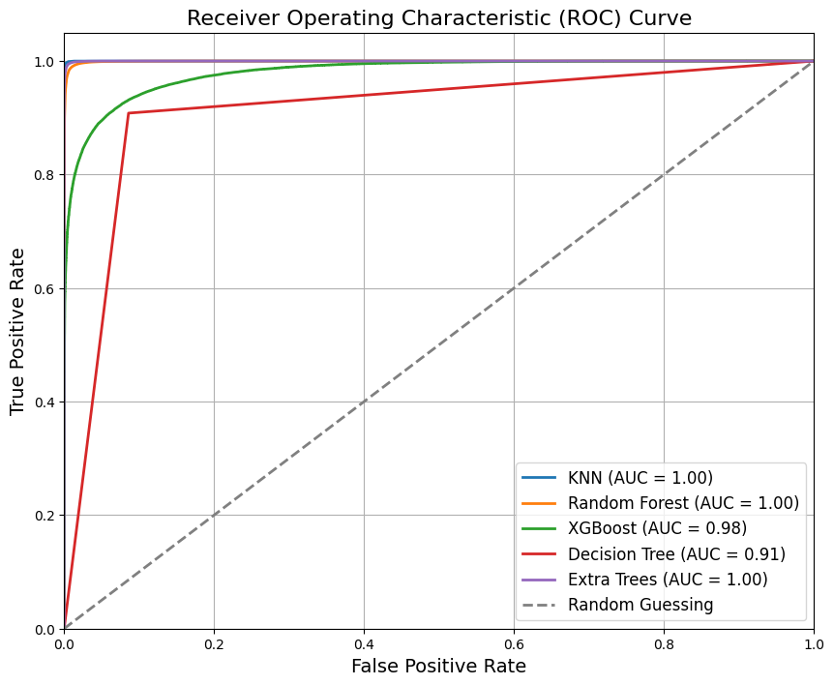

**Figure:** ROC Curve for Machine Learning Results using 16 Features with Feature Importance ≥ 0.60.

**Classification Reports – 16 Features**

**KNN:**

**precision recall f1-score support**

0 1.00 1.00 1.00 77676

1 1.00 1.00 1.00 77614

accuracy 1.00 155290

macro avg 1.00 1.00 1.00 155290

weighted avg 1.00 1.00 1.00 155290

**Random Forest:**

**precision recall f1-score support**

0 0.98 0.99 0.99 77676

1 0.99 0.98 0.99 77614

accuracy 0.99 155290

macro avg 0.99 0.99 0.99 155290

weighted avg 0.99 0.99 0.99 155290

**XGBoost:**

**precision recall f1-score support**

0 0.91 0.94 0.92 77676

1 0.94 0.90 0.92 77614

accuracy 0.92 155290

macro avg 0.92 0.92 0.92 155290

weighted avg 0.92 0.92 0.92 155290

**Decision Tree:**

**precision recall f1-score support**

0 0.91 0.91 0.91 77676

1 0.91 0.91 0.91 77614

accuracy 0.91 155290

macro avg 0.91 0.91 0.91 155290

weighted avg 0.91 0.91 0.91 155290

**Extra Trees:**

**precision recall f1-score support**

0 0.99 1.00 0.99 77676

1 1.00 0.99 0.99 77614

accuracy 0.99 155290

macro avg 0.99 0.99 0.99 155290

weighted avg 0.99 0.99 0.99 155290

**Confusion Matrix - 16 Features**

